 | Personal Dev. | Emotional Wellbeing | Culture
Age4 & Under | First impressions are so important for both players and parents alike. New members welcomed with open arms. Creating as fun and as enjoyable an environment as possible for young players. Coaches are positive and energetic. Biggest indication of a successful session will be players smiling and wanting to return the following week. Encourage as many parents as possible to get actively involved. This is the perfect opportunity for them to join the club community as coaches, social events etc. and most importantly their child’s supporter
Age 4 & 5 | Try to get to know their team mates and ideally form new friendships | Have opportunities to also enjoy family events within the club such as seasonal parties, BBQs, movies nights etc. | Welcoming-Each player feels like they are an important part of the club / community. They are warmly welcomed to training & feel appreciated.
Under7s | Identify themselves as being an important part of a team who will be there for them | Players support their teammates and they do likewise. Encouragement after a mistake, help executing a skill etc. Give support-Feel supported | Part of a team-Players begin to identify themselves as individuals who are all part of the same team. Work together & encourage one another. Strong sense of unity
Under9s | Developing a passion for GAA Creates a great drive within, motivator & a positive focus | Gaelic games growing as a key element of their lives. A positive social outlet whilst learning important lessons around discipline, respect also | Developing a love for Gaelic Games-Encouraging players to watch & learn from senior teams within club & county teams / stars from all over the country
Under11s | Growing in confidence & more open to discussing emotions & giving opinions | Learning how manage emotions through the highs and lows involved in sport. These skills will transfer to other important life scenarios | Coachable-Players show a willingness to learn. Trust their coaches and team mates. Open to constructive criticism. Happy to work at improving their game
Under13s | Being kind to themselves & others especially when things aren’t going to plan. CREID | 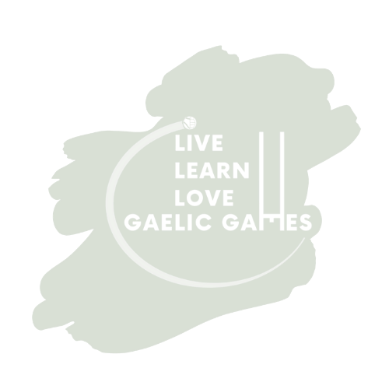  Dealing with setbacks effectively. Aware of the fact that mistakes will happen in games/training and that it’s ok. Mistakes=Learning Experiences | CREID/Believe-Players tackle challenges head on. Believe in their own ability and with the support of team mates/coaches that all ambitions are achievable
Under15s | Self-esteem growing as they feel BRÓDÚIL of the fact that they are GAA players | Aware of the many positive/negative distractions at this stage of their lives but BRÓDÚIL of their emotional bond with their club & healthy lifestyle | BRÓD/Pride-Feeling a great sense of pride in representing their club. Being proud of the effort that they and their team mates put into games/training
Under17s | Responsibility-Train, play & behave like role models for younger CLANN members | Looking after themselves and other members of our CLANN on & off the field. Discuss highs / lows of life as they would the ups & downs of games | CLANN/Family–View their club like a second big family. Treat all members with respect. Do whatever it takes to improve the fortunes of our family. Be part of our legacy!

